**SMART SYSTEM FOR OPTIMIZED ORGANIC CROP**

**ROTATION USING PRECISION AGRICULTURE DATA**

Ihalagedara I.H.U.B

(IT20224820)

Bachelor of Science Special (Hons) in Information Technology Specialization in Software Engineering

Department of Computer Science and Software Engineering

Sri Lanka Institute of Information Technology

Sri Lanka

September 2023

**SMART SYSTEM FOR OPTIMIZED ORGANIC CROP**

**ROTATION USING PRECISION AGRICULTURE DATA**

Ihalagedara I.H.U.B

(IT20224820)

Dissertation submitted in partial fulfillment of the requirements for the Bachelor of Science (Hons), Information Technology, Specialization in Software Engineering

Department of Computer Science and Software Engineering

Sri Lanka Institute of Information Technology

Sri Lanka

September 2023

DECLARATION

I declare that this is my own work when considering my individual components of the research,and this dissertation does not incorporate without acknowledgment any material previously submitted for a degree or diploma in any other university or institute of higher learning and to the best of our knowledge and belief it does not contain any material previously published or written by another person except where the acknowledgment is made in the text.

|  |  |  |
| --- | --- | --- |
| Name | Student ID | Signature |
| Ihalagedara I.H.U.B | IT20224820 |  |

The above candidates are carrying out research for the undergraduate Dissertation under my supervision.

Signature of the supervisor Date

ABSTRACT

When we take the modern world, agriculture has become one of the key areas that can

affects the economy of the country. Due to many reasons like economic issues and health issues, organic cultivations have become more popular time to time. Although the organic cultivation is there, most of the people do not have much knowledge about the process, ways we can optimize the cultivation and managing pests and diseases. Hence, even though organic cultivation has its benefits, without a common reading about the process it can be costly.

The concept of organic cultivation with the crop rotation can be an efficient and effective way cultivation not only for commercial usages but also for the domestic usages. So, having a platform where we can get and manage all the necessary data and information will be so useful for the day to day life activities.

Even though we full fill all the requirements pests and diseases can play a major role when it comes to the productivity of the cultivation. This can be challenging for the larger organizations. If we take a specific disease or a pest, there are so many organic ways of controlling those pests or diseases which most of the people doesn’t know.

This research involves in providing a solution to identify pests or diseases through a cloud computing and machine learning based developed model and provide all the information about it including a description and ways of handling them in organic methodologies.

Keywords - cloud computing, machine learning, crop rotation, organic

cultivation

ACKNOWLEDGEMENT

I would like to express my sincere gratitude and appreciation to my supervisor, Mr Udara Samaratunga, and co-supervisor, Dr. Nuwan Kodagoda, for their invaluable guidance, encouragement, support, and dedication throughout my one-year research journey. Their advice and assistance have been continuous support in guiding the direction of our research project(RP) and making it a success without any undue pressure. I am truly grateful for their constant availability and willingness to help whenever needed and it was a great privilege to work with them during this research. I also extend my heartfelt thanks to Dr. Jayantha Amararachchi, the Lecture in Charge of the Research Module, for his insightful lectures and constant guidance throughout one year that has helped me to understand the research module more thoroughly. My parents deserve a special mention for their unending support and care throughout my academic journey. Their limitless support has been a source of inspiration and motivation for me to reach my academic goals. I would also like to thank my three group members for their continuous commitment, team spirit, and hard work throughout this research journey that has made this research project a success. It has been an honor to work with such a dedicated team, and I am grateful for their support and encouragement. Finally, I would like to express my sincere gratitude to the research panel, TAF Panel, and CDAP staff for their valuable advice, instructions, and time and for accepting our research topic by giving us the chance to do this research.

Table of Contents

DECLARATION II

ABSTRACT III

ACKNOWLEDGEMENT IV

LIST OF FIGURES VII

LIST OF TABLES VIII

LIST OF APPENDICES IX

LIST OF ACRONYMS AND ABBREVIATIONS X

1. Introduction 11

1.1 Background & Literature Survey 12

2. Research Gap 15

3. RESEARCH PROBLEM 16

4. OBJECTIVES 18

4.1 Main Objective 18

4.2 Specific Objectives 18

5. METHODOLOGY 19

5.1 Problem Statement 19

5.2 Requirement Gathering and Analysis 20

5.3 System Design and Implementation 20

5.3.1 Overall System Diagram 21

5.3.2 Individual System Diagram 22

5.4 Data Collection 22

5.5 Implementation 23

5.5.1 Creating the Pest Classification Model 23

5.6 Deployment and Maintenance 29

5.7 Tools and Technologies 29

5.8 Commercialization 29

6. TESTING & IMPLEMENTATION 31

6.1 Test Plan and Strategy 31

6.2 Test Case Design 32

7. RESULTS & DISCUSSION 38

7.1 Results 38

7.2 Research Findings 40

7.3 Discussion 41

8. CONCLUSION 43

REFERENCES 44

APPENDIX A: SURVEY 45

APPENDIX B: WORK BREAKDOWN CHART 45

APPENDIX C: GANTT CHART 46

APPENDIX D: PLAGIARISM REPORT 46

LIST OF FIGURES

Figure 3‑1 YOLO system architecture 17

Figure 8‑1Application images 1 47

Figure 8‑2 Application images 2 48

LIST OF TABLES

Table 2.1Comparition of the system 16

LIST OF APPENDICES

LIST OF ACRONYMS AND ABBREVIATIONS

|  |  |  |
| --- | --- | --- |
| **Abbreviations**  RP  SLIIT  CRM  UI  IOT  DB  CSI  UX | **Description**  Research Project  Sri Lanka Institute Of Information Technology  Crop Rotation Management  User Interface  Internet Of Things  Database  Crop Sutaibility index  User Experience | |
|  | |  |

# Introduction

Agriculture plays a crucial role in the global economy by providing food, fiber, and raw materials to various industries. However, conventional or artificial farming methods have been found to have negative impacts on the environment, such as soil degradation, water pollution, and a loss of biodiversity [1]. As a result, there is a growing demand for agricultural practices that prioritize social fairness, economic viability, and environmental protection. Organic farming, which focuses on natural inputs and the preservation of soil health, is a promising alternative. Organic crop rotation, which involves rotating crops to improve soil fertility, reduce soil erosion, and control pests and diseases, is a critical part of organic farming. Additionally, soil analytics, which uses advanced technologies to monitor soil properties such as moisture, temperature, and nutrient levels, is another essential aspect of organic farming. With the help of organic crop rotation and soil analytics, farmers can make informed decisions about crop selection and management, which can increase output and profitability while minimizing negative environmental impacts. To further enhance sustainable agricultural practices, we propose the development of a software program that integrates soil analytics with organic crop rotation. This software program will use IoT sensors to collect real-time data on soil parameters, crop growth, and environmental variables. These data will be processed with an optimization algorithm to determine the most optimized crop for the given soil sample. Furthermore, the software program will integrate a knowledge base covering top techniques for pest management, soil health management, and organic crop rotation. 6 In addition to the optimization algorithm, we suggest incorporating machine learning models to enhance the software's analytical capabilities. By using machine learning, the software program can learn from data collected from previous farming seasons to offer more accurate predictions and recommendations for future crop rotations. Our project aims to promote the adoption of sustainable and resilient agricultural practices that benefit both the environment and farming communities. By providing farmers with access to advanced technologies and knowledge sources, we hope to help build a more resilient and sustainable food system for future generations.

## Background & Literature Survey

Not only is agriculture a key component of Sri Lanka's economy, but it also serves as a potent barometer of the wellbeing of the populace. Over the course of its lengthy history, Sri Lanka has been recognized for its sophisticated agricultural methods, which are marked by a wealth of information and cutting-edge technologies that are indispensable to daily existence. Because agriculture is so ingrained in the country's culture, Sri Lankans have a thorough awareness of weather patterns, fertilizer management, and how to recognize and control pests and illnesses that impact their crops. These age-old techniques, which have been passed down through the centuries in the absence of contemporary technologies, are the basis of Sri Lanka's agricultural legacy.

Agriculture continues to be a vital part of the national economy in the modern world. Nevertheless, it faces a number of difficulties, with illnesses and pest infestations posing serious risks to crop output and the means of subsistence for millions of farmers. Due to their hectic schedules and insufficient understanding, modern farmers are more likely to turn to chemical remedies in the hopes of achieving faster results and higher yields. However, these short solutions have a number of long-term drawbacks even though they could provide comfort right now. These include depletion of soil fertility and entry of toxic chemicals into the human food chain, highlighting the crucial problem of inadequate understanding of sustainable management of pests and diseases, including the use of organic alternatives.

It is impossible to exaggerate the importance of efficient pesticide management in agriculture. It has a major impact on crop yield as well as the general caliber of agricultural products. The large-scale cultivation of rice fields in Sri Lanka during the "Maha" and "Yala" seasons—which encompass around 0.8 million hectares and employ about 1.8 million farmers—illustrates the discernible increase in pesticide consumption over time. These agricultural businesses are especially vulnerable to insect infestations due to their sheer size, which emphasizes the need for effective pest management techniques.

Two fundamental elements in the field of pest management are precise pest identification and prediction skills. Failing in this area can lead to significant losses in terms of time, money, and crop productivity. Thus, the purpose of this study is to present a thorough method for identifying pests and illnesses in agriculture, provide in-depth understanding of these problems, and suggest preventive actions based on crop rotation, an organic farming technique.

This study's main goal is to enable users to recognize illnesses and pests from the photographs they submit. In addition to providing a thorough description of the detected pest, the study will provide organic means of control and avoidance. Furthermore, the study investigates a different strategy for identifying diseases based on leaf color analysis, a technique often used in rice production called the Leaf Color Chart (LCC), which measures the plant's need for nitrogen. It is important to remember that earlier studies in this area have been conducted, as will be explained below.

An example of a research work that explores insect classification via the lens of machine learning is "Insect classification and detection in field crops using modern machine learning techniques," written by Thenmozhi Kasinthan, Dakshayani Singaraju, and Srinivasulu Redy Uyyala. Using machine learning techniques such as artificial neural networks (ANN), support vector machines (SVM), and k-10 closest neighbors (KNN), the study explores the classification of insects into nine different classifications. One notable achievement was a classification rate of 91.5%, especially for twenty-four distinct classes, made possible by the use of convolutional neural network (CNN) models. Three primary techniques of this suggested system are picture pre-processing, image augmentation, and dataset categorization.

"Insect pest image recognition, including maturity stage classification," carried out by Dibio L. Borges and Jaco C. Gomes, is another noteworthy scientific project. The two pest stages that need to be identified for this investigation are the "early stage" and the "adult stage." Using a specific statistic called the Kullback-Leibler divergence, the experiment produced impressive results: 86.33% accuracy rate for adults and 87.91% accuracy rate for the early stage. The experiment used a dataset with 6817 photos total, divided into 45 classes of early-stage insects and 97 classes of mature insect images. The implementation included convolutional neural networks and other machine learning elements, and it was built on an automated computer vision system.

In conclusion, using Sri Lanka as an example, this thorough background and literature review highlights the critical role that pest and disease control plays in agriculture. It highlights the promising studies using cutting-edge machine learning approaches to improve pest and disease identification within the agricultural domain and throws light on the significance of implementing organic remedies, such as crop rotation. These research projects protect the long-term health and productivity of Sri Lanka's agricultural sector by acting as rays of hope for the development of ecologically friendly, sustainable, and productive pest management techniques in the future.

This dedication to sustainable agriculture is a reflection of a larger worldwide movement toward ethical and environmentally conscious farming methods, which are essential for the health of our planet and the success of our country. We shall go even further into the problems and solutions in Sri Lanka's agriculture industry in the pages that follow, giving you a more thorough grasp of the difficulties and possibilities that the country faces.

We need to go back in time to understand how these ancient agricultural practices have influenced Sri Lanka's history and culture in order to have a greater understanding of the nation's agricultural legacy. The expertise and experience that have been passed down over the years provide witness to the adaptability and tenacity of Sri Lankan farmers, who have succeeded in thriving in a setting that is continuously changing.

In Sri Lanka, agriculture plays a significant role in both the country's economy and culture. The traditional methods have given important insights into resource management and production maximization with minimal negative environmental effects. These tried-and-true methods are invaluable resources that have the power to influence Sri Lankan agriculture's future.

Moreover, the difficulties that Sri Lankan farmers confront today are not specific to the country; rather, they are universal. Sri Lanka's experience can be a useful case study as the globe struggles with problems including excessive use of pesticides, environmental deterioration, and the requirement for sustainable agriculture techniques. The cutting-edge techniques, such crop rotation and machine learning for pest identification, provide a window into a more sustainable agricultural future for the entire world as well as Sri Lanka.

Tradition and modernity meet at the junction of Sri Lanka's agricultural sector's spread of knowledge and innovation. It is evidence of the human spirit's adaptability and capacity to fuse the knowledge of the past with the cutting-edge innovations in technology. This study's holistic approach to managing pests and diseases has the potential to completely transform agriculture—not just in Sri Lanka, but all throughout the world.

In summary, Sri Lanka's agriculture industry is a complex fabric of innovation, tradition, and the pressing need for sustainable methods. It's an amazing journey from traditional farming knowledge to contemporary machine learning and organic solutions. It emphasizes how crucial it is to maintain old knowledge while embracing new innovations and environmentally friendly practices. Sri Lanka provides insightful information to the globe in its quest for a more sustainable and prosperous future as it continues to manage the difficulties of contemporary agriculture.

# Research Gap

The primary goal of this research is to develop a pest and disease identification mechanism and provide the available organic solutions so that the user can work on their own plantation. When the user has this kind of a system with them even though they are involving in an enterprise level or domestic level of cultivation, they still can use this system to get the advices through a knowledge-based system for their organic cultivation. A thorough study of the existing similar solutions has been made and it is identified that the neither of the existing systems does not support for the organic cultivation in Sri Lanka. Different kind of object detection mechanisms or methodologies are available, but neither of them is providing further information about the detected pest or the disease. The proposed systems are capable of identifying the pests or the diseases through an image and provide the necessary guidelines for the future references with a knowledge-based system. The initial discussion came to place with the research report “Possibilities to minimize pesticide usage in Sri Lankan paddy cultivation: An emphasis on risk management” [10]. We can identify some challenges that people faced when it comes to the organic cultivations and lack of knowledge about the agricultural area like pests and diseases. So even though we can find already existing systems to identify pests and diseases we can provide additional measures to develop or help the growth of the cultivation. When we go through the publications [7,8], we can identify the above facts that a system is proposed using machine learning features like convolution neural network (CNN) and computer vision, neither of them provide a solution for those identified problems for the organic cultivation. Another way to accomplish this task is to use the cloud computing platforms like azure and use their cognitive service and use algorithms like YOLO.

Table .Comparition of the system

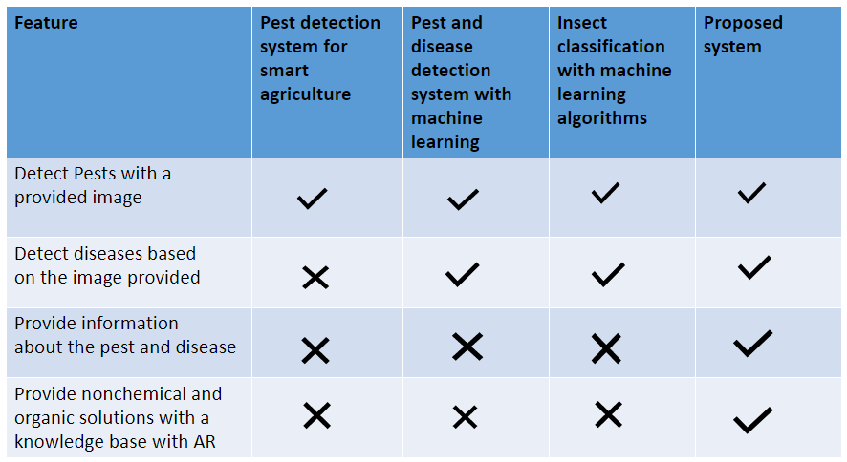

# RESEARCH PROBLEM

An important research problem in sustainable agriculture is the lack of integrated software solutions that combine organic crop rotation and soil analytics, including the utilization of gathered soil data with an optimization algorithm, potentially powered by a machine learning model, to find the most optimized crop. Existing methods that target only one aspect of sustainable agriculture do not provide farmers with a comprehensive approach to managing their farms, leading to poor yields and environmental damage. The main challenge in creating an integrated software solution is developing a user-friendly platform that combines real-time information about soil health, crop growth, and environmental variables, and incorporates best practices for organic crop rotation and soil health management. To achieve this, it is crucial to simplify the integration of IoT sensors and knowledge sources into a single platform that can be customized to meet the specific needs of different farming communities. Additionally, it is essential to evaluate the efficacy of such a software program in different farming situations to ensure that it can enhance farm productivity and profitability while promoting sustainable and environmentally friendly practices. Therefore, the research goal is to develop and test an integrated software system that combines organic crop rotation with soil analytics, optimization algorithm potentially powered by a machine learning model, and incorporates the use of gathered soil data to find the most optimized crop. Our proposed software solution could help promote more effective and sustainable agricultural practices while enhancing farm productivity and profitability, addressing this critical research topic.

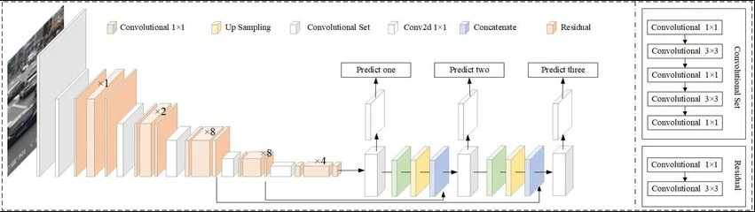

Figure ‑ YOLO system architecture

With use of the proposed system another goal is to minimize the time and the cost required to identify and manage diseases and pests. For those who does not have the knowledge about the organic treatments, they will have to do some research by looking on internet, reading a book or having a discussion with a well-known person about the specific field. So, unlike other available systems this will provide the necessary measures without any time delay with the help of knowledge-based system. According to the proposed system, user will be able to interact through a web-based application and get the necessary solutions

# OBJECTIVES

## Main Objective

The goal of this research project is to create a web-based system that incorporates augmented reality (AR) to handle agricultural pest and disease control. The system will reliably identify and classify illnesses and pests using sophisticated picture analysis techniques led by computer vision and machine learning. After identification, the system will provide customers sustainable and organically based non-chemical solutions that prioritize crop health over the long term and environmental responsibility.

In addition to being a tool, the system will act as a decision-support system, giving farmers and other stakeholders important information they need to make wise decisions. This all-encompassing, technologically advanced solution blends traditional sustainable agricultural knowledge with state-of-the-art digital innovation within an intuitive web-based platform. By incorporating AR, the system is brought to a new level where the digital and physical worlds coexist together, offering a revolutionary solution to problems facing agriculture.

The goal of the research thesis is to reinvent agricultural issues management and strategy by focusing on sustainability, accessibility, and innovation. This innovative technology, powered by augmented reality and sophisticated picture analysis, has the potential to completely transform the agricultural industry by providing farmers and other stakeholders with a priceless tool for ensuring the health and success of their crops.

## Specific Objectives

Below mentioned points are some sub objectives about the research.

Improving disease and pest management in agriculture is the main goal of this research. It entails encouraging conventional organic farming, leveraging bespoke vision for machine learning, and visually analyzing the effects of pests. The objective is to develop a clever solution that provides non-chemical solutions for well-informed decision-making. The compilation of the dataset, pre-processing, model selection, and training for expense classification are important phases. The research combines tradition and technology to promote sustainable agriculture.

* To capture and understand the visual impacts on plants by the pests
* To understand some techniques related to machine learning like custom vision and train a model
* To understand about the traditional organic crops and non-chemical pesticides for a productive cultivation.
* To provide a smart solution to provide decisions to the user.
* Creating a proper dataset to train the machine learning model
* Pre-process the dataset to give accurate results
* Select an appropriate machine learning model to classify expenses.
* Train the machine learning model using pre-processed dataset.
* Select the highest accurate machine learning(ml) model to classify expenses.

# METHODOLOGY

The main intention of this component is to provide a web-based application to capture the unknown pests and diseases through a trained model and provide the user with the necessary non-chemical or natural solutions with the concept of crop rotation. Once the image is provided it will go through a trained model and identify the creatures or defected areas with the YOLO algorithm object detection with the use of flask server. Then the necessary data will be filtered and displayed according to the identified results from the knowledge-based system. Other than that, yolo algorithms are planned to use to identify the colors of the leaves and necessary Nitrogen usage for those crops. As a summarization we can mention the below points about the methodology of this component.

• Identify the pests and leaf diseases through YOLO algorithm trained model.

• Identify the leaves color differences with the YOLO algorithm.

• Provide collected organic or natural solutions through a knowledge-based system according to the identified results.

• Provide valuable information and decisions for the crop rotation of the field.

## Problem Statement

Improving disease and pest management in agriculture is the main goal of this research. It entails encouraging conventional organic farming, leveraging bespoke vision for machine learning, and visually analyzing the effects of pests. The objective is to develop a clever solution that provides non-chemical solutions for well-informed decision-making. The compilation of the dataset, pre-processing, model selection, and training for expense classification are important phases. The research combines tradition and technology to promote sustainable agriculture.

## Requirement Gathering and Analysis

Gannoruwa agriculture research center As one of the key requirements gathering areas, we have identified Gannoruwa agriculture research center to gather information and data about the organic crop 21 production and crop rotation. Since they are involving in the organic cultivation the research center is capable of providing the necessary data about the

## System Design and Implementation

### Overall System Diagram

Improving disease and pest management in agriculture is the main goal of this research. It entails encouraging conventional organic farming, leveraging bespoke vision for machine learning, and visually analyzing the effects of pests. The objective is to develop a clever solution that provides non-chemical solutions for well-informed decision-making. The compilation of the dataset, pre-processing, model selection, and training for expense classification are important phases. The research combines tradition and technology to promote sustainable agriculture.

### Individual System Diagram

The YOLOv5 algorithm is utilized by our research component to provide increased capabilities in identifying pests based on supplied photographs, with a particular focus on advanced pest identification.

Integration of Augmented Reality: We incorporate Augmented Reality (AR) to further enhance pest detection. With AR overlays, this cutting-edge technology improves user experience by providing real-time pest recognition.

Tailored Solutions: Our system goes above and beyond simply identifying pests. Following a pest's identification, it provides users with information and direction by providing specialized, suitable treatments.

Preparing the Dataset: We know that a solid dataset is essential to a successful model training process. We source, curate, and augment datasets as part of our research component to make sure the YOLOv5 model is trained with the best possible data.

With its all-encompassing strategy, pest control is about to undergo a revolutionary change, offering users a potent, technologically advanced crop protection and sustainable agricultural solution.

## Data Collection

Our machine learning model is based on the painstaking compilation of a dataset with about 6,400 photos covering 15 different pest classes. Every picture has a detailed label, and each file has a label that corresponds to it. Our YOLO model uses this dataset as a foundation to be accurately recognized and classified as a pest.

Understanding how crucially important high-quality datasets are, we also augmented the dataset to make it more robust. The method of augmentation guaranteed that our model is capable of managing a wide range of real-world scenarios and variances.

A good dataset is essential for effective model training. It creates a link between theory and real-world application, allowing the model to grow and change efficiently. A thorough and properly annotated dataset is essential for accurate, dependable, and useful results in the field of pest identification. This way, our technology can yield insightful information for agricultural pest control.

## Implementation

### Creating the Pest Classification Model

Install the YOLO framework along with any necessary libraries and dependencies.

In order to train models, several tools are required. Separate file is created for the requirements. Once the file is loaded, necessary libraries will be installed.

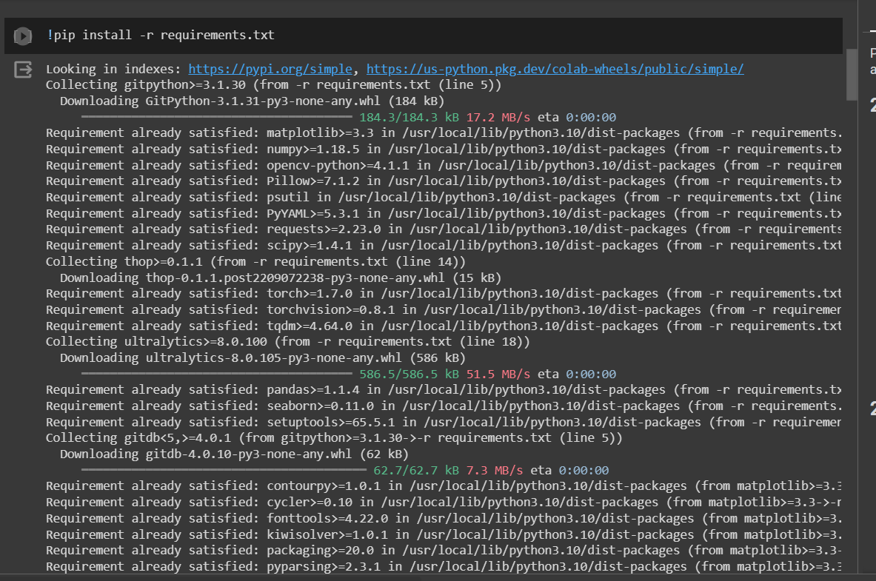

The dataset loads into Google Colab without any problems. Prior to this, a careful data augmentation procedure was used to improve training dataset visibility and adaptability, making sure the dataset is ready for the next steps of the training process.

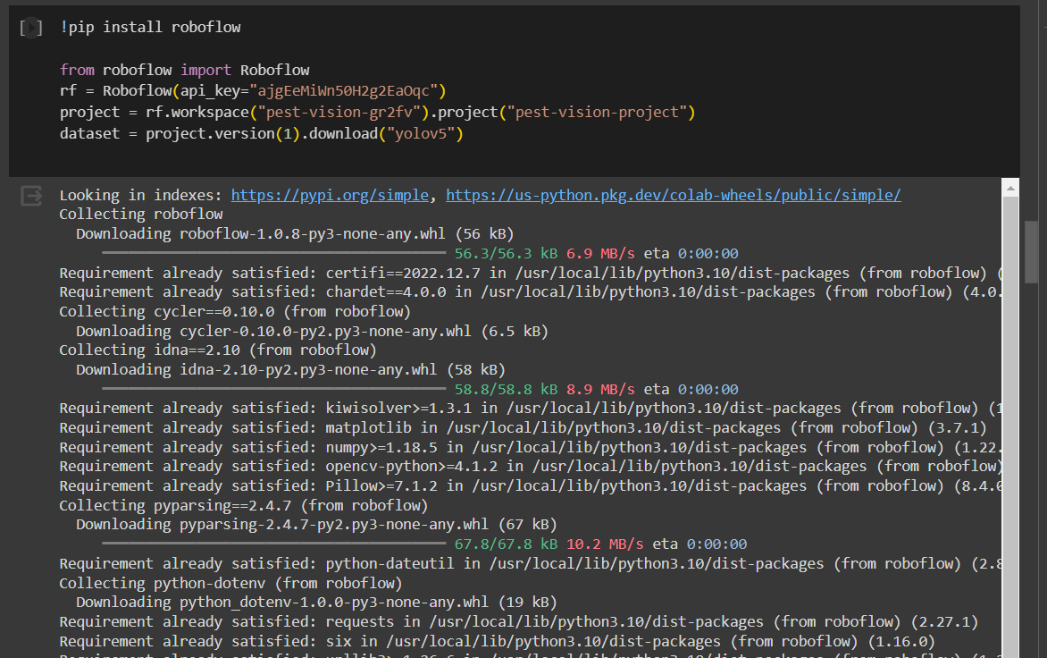

One of the most important steps in preparing a dataset is to carefully divide the data into subsets for testing and training. In machine learning, this division is essential because it sets aside a section of the dataset for model training and another for validation and testing. In doing so, it prevents overfitting and improves the model's overall reliability by allowing a thorough assessment of its performance and guaranteeing that the model's generalization skills go beyond the training set.

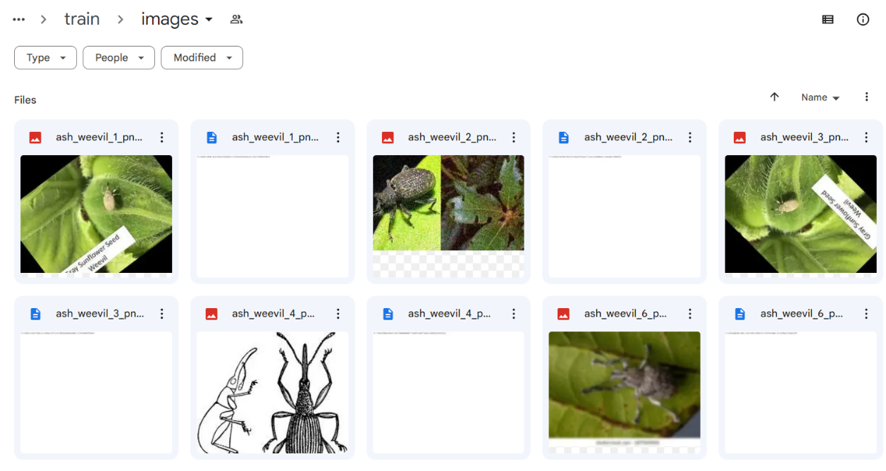

Model training with the loaded dataset. This has been trained within 50 epochs.

After training, the YOLO (You Only Look Once) method outputs the generated model weights. The Flask server, which serves as a platform for users to engage with the model and receive real-time object detection predictions, incorporates these weights. Effective and real-time prediction skills are made possible by this smooth integration, which takes the YOLO model from the training stage to real-world application. A screenshot of a computer

Testing the created weighted model by providing an image to get the predictions.

Our project involves using React Native to create a mobile application from scratch. This program will function as a front-end interface that is responsive and dynamic. In addition, we're using Flask to help us build a solid backend infrastructure. To facilitate seamless connection between the front-end and back-end components, a set of APIs that manage data and user interactions will be hosted by the Flask server.

We have selected Firebase as the database option in order to improve data storage, retrieval, and overall application efficiency. Firebase, which is renowned for its scalability and real-time capabilities, will offer a smooth and quick user experience.

React Native is used for the mobile application, Flask is used for backend APIs, and Firebase is used for data storage. This combination of technologies results in a mobile application that is both flexible and easy to use. An application with many features, excellent connectivity, and great efficiency for a range of use cases will be the end product.

## Deployment and Maintenance

## Tools and Technologies

* Python
* Jupyter Notebook
* React-Native
* Firebase
* PuTTY
* AWS
* Google Colab
* Numpy
* React Native
* Vs Code

## Commercialization

Not just enterprise-level users will be able to utilize the system we're developing for the identification of pests and diseases and the supply of natural, non-chemical solutions. It is intended to benefit home users just as much. This adaptable web application is designed to serve a wide range of users, including farmers, agriculture professionals, and anybody else involved in crop production.

Furthermore, the design of our system is centered on user-friendliness. To increase user appeal and make the program accessible to users of various backgrounds and skill levels, we place a high priority on an intuitive interface.

This system is intended for a wide range of users, including researchers, farmers, students studying agriculture, organic crop producing firms, and stakeholders. Essentially, it's a multifaceted instrument that unites different agricultural stakeholders.

Numerous databases pertaining to pests, crop illnesses, and their remedies are utilized by our system. Our goal is to help manage pests and diseases by giving users useful and accurate information by utilizing cloud computing and machine learning methods.

Target audience

• Researches

• Farmers

• Agriculture students

• Organic crop production companies

• Stakeholders

• All of the domestic users Market Space

• No age limitations for the users

• No prior knowledge is required

• Basic knowledge would be enough to use the web application

Our market's inclusiveness is what makes it unique:

People of all ages can use it because there are no age restrictions for users.

It is not necessary to have any prior specialized knowledge to utilize and navigate the online application. To ensure usability for a broad spectrum of users, from beginners to professionals in the field of agriculture, a basic understanding is sufficient.

# TESTING & IMPLEMENTATION

## Test Plan and Strategy

Developing a strong test strategy and plan is essential to software development in order to guarantee the performance and dependability of the product. The test plan functions as a thorough document that outlines the goals, objectives, and particular tasks needed for testing for the project. On the other hand, the test strategy is a collection of rules that control the software testing procedure; it specifies the features and components that will be examined and evaluates any possible dangers to the user.

Software testing can only be successful with a well-organized test strategy and plan. They improve the final product's quality and dependability by facilitating early problem discovery.

The test plan serves as a guide for carrying out software testing at the appropriate calibre. It includes the following crucial actions:

1. Define the Testing Scope: Choose the features of the programme that require testing. By defining the parameters of testing, this stage guarantees that no crucial features are overlooked.

2. Identify Critical Functions: Emphasise the functions that are most important to users and those who are at higher risk. Providing a dependable product requires giving testing for these components top priority.

3. Test Case Development: Using use case descriptions as a guide, create test cases. Testers can evaluate the software's performance in a variety of settings by using these test cases, which mimic real-world situations.

4. Execution of Test Cases: Carry out the prepared test cases and carefully document the results. Finding any differences between the expected and actual results depends on this phase.

5. Finding bugs: While testing, find and record any problems or bugs that crop up. Good documentation is necessary for effective troubleshooting.

6. Fixing bugs: Take care of and fix any issues that were discovered during testing. This stage is essential for removing software bugs and guaranteeing a reliable final result.

7. Iterative Testing: Run the test cases again and again until the desired outcomes are consistently obtained. By using an iterative process, the software is guaranteed to satisfy the required performance and quality standards.

8. In conclusion, an organised and methodical approach to software testing is provided by a well-structured test plan and strategy. These papers make it easier to find and fix errors, improving the quality and dependability of the finished product and satisfying user and stakeholder expectations.

## Test Case Design

|  |  |
| --- | --- |
| Test Case ID | 01 |
| Test Case | Classify Ash weevil |
| Test Scenario | Classify Ash weevil to the correct category |
| Input | Ash weevil |
| Expected Output | Ash weevil |
| Actual Result | Ash weevil |
| Status(Pass/Fail) | Pass |

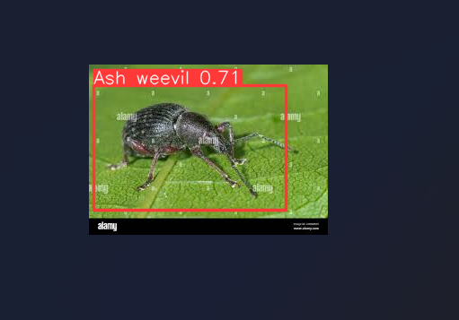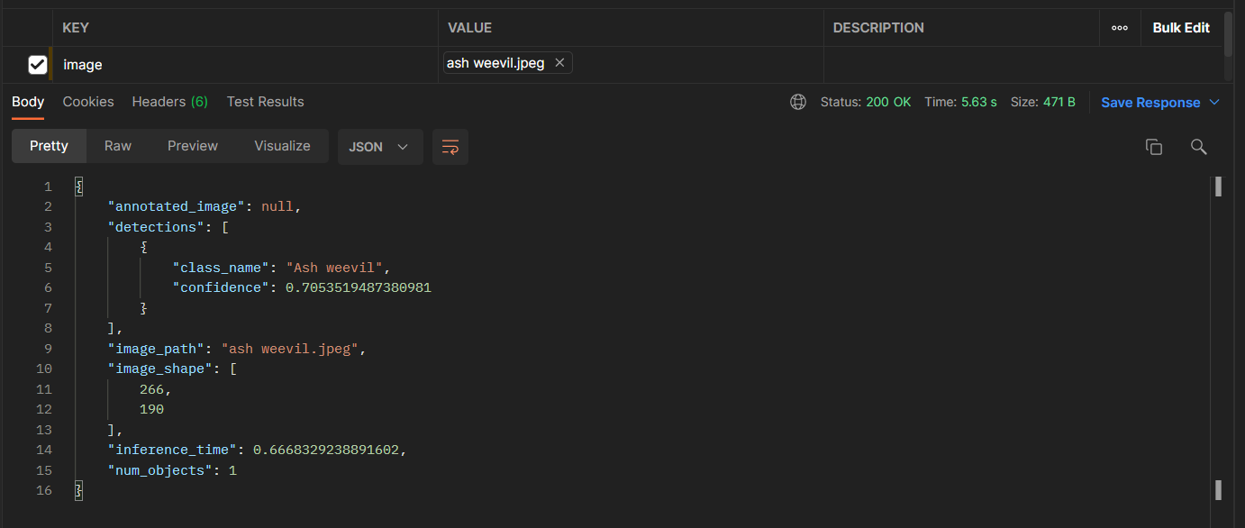

|  |  |
| --- | --- |
| Test Case ID | 02 |
| Test Case | Classify Mealy Bug |
| Test Scenario | Classify Mealy Bug to the correct category |
| Input | Mealy Bug |
| Expected Output | Mealy Bug |
| Actual Result | Mealy Bug |
| Status(Pass/Fail) | Pass |

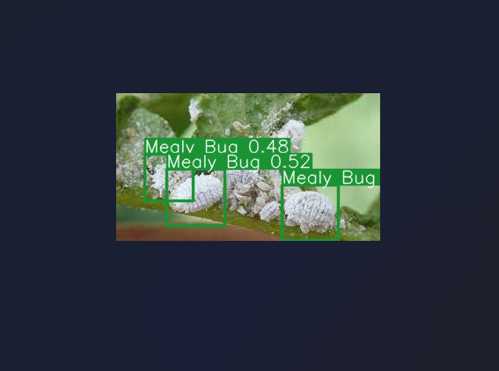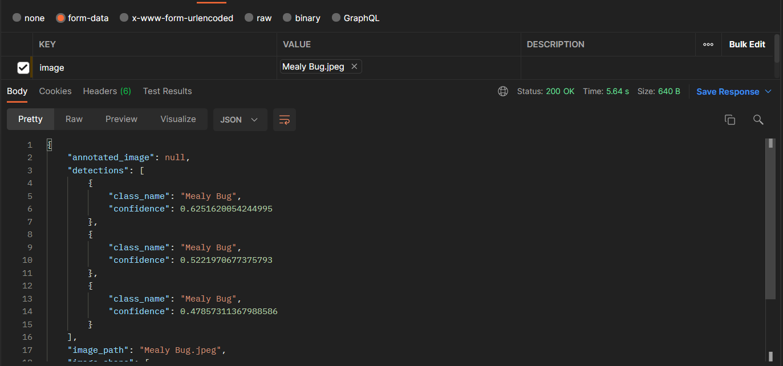

|  |  |
| --- | --- |
| Test Case ID | 03 |
| Test Case | Classify Blister Beetle |
| Test Scenario | Classify Blister Beetle to the correct category |
| Input | Blister Beetle |
| Expected Output | Blister Beetle |
| Actual Result | Blister Beetle |
| Status(Pass/Fail) | Pass |

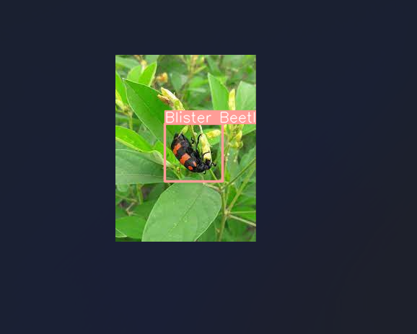

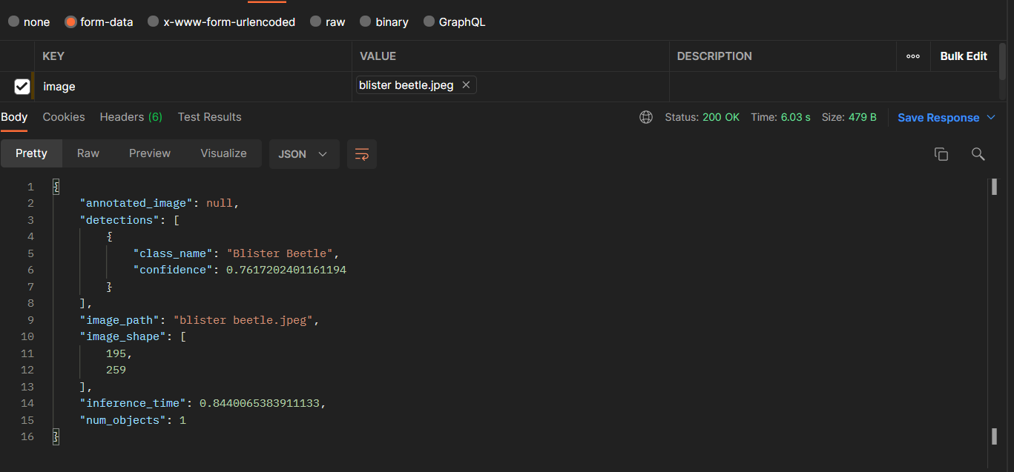

|  |  |
| --- | --- |
| Test Case ID | 04 |
| Test Case | Classify White fly |
| Test Scenario | Classify White fly to the correct category |
| Input | White fly |
| Expected Output | White fly |
| Actual Result | White fly |
| Status(Pass/Fail) | Pass |

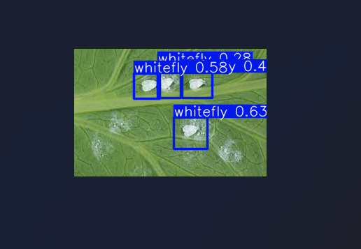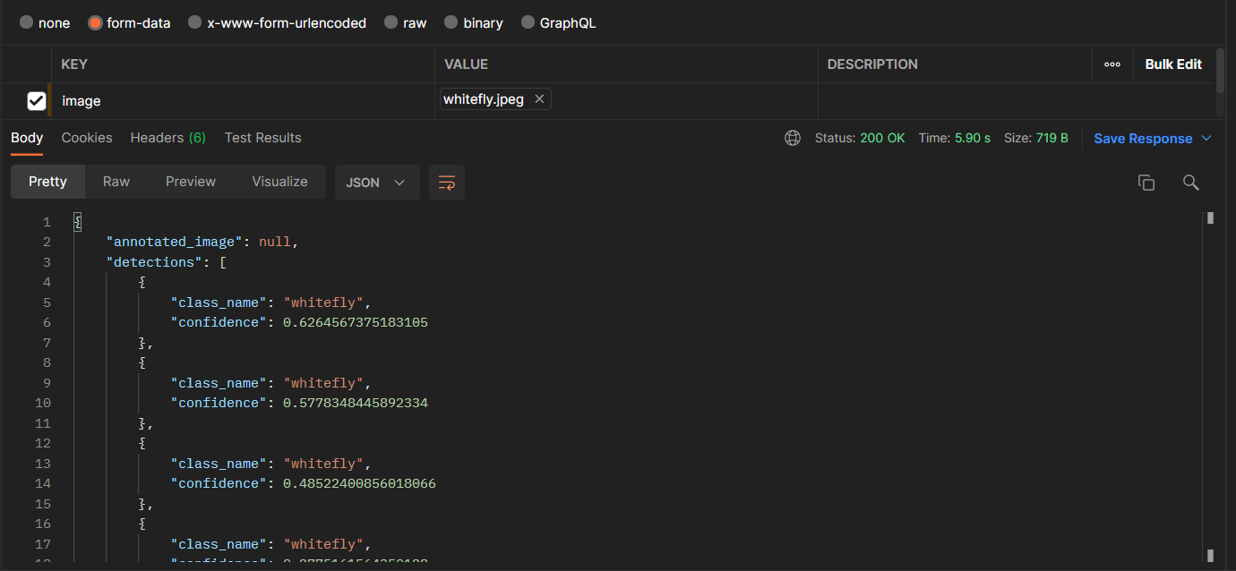

|  |  |
| --- | --- |
| Test Case ID | 05 |
| Test Case | Classify Uroleucon |
| Test Scenario | Classify Uroleucon to the correct category |
| Input | Uroleucon |
| Expected Output | Uroleucon |
| Actual Result | Uroleucon |
| Status(Pass/Fail) | Pass |

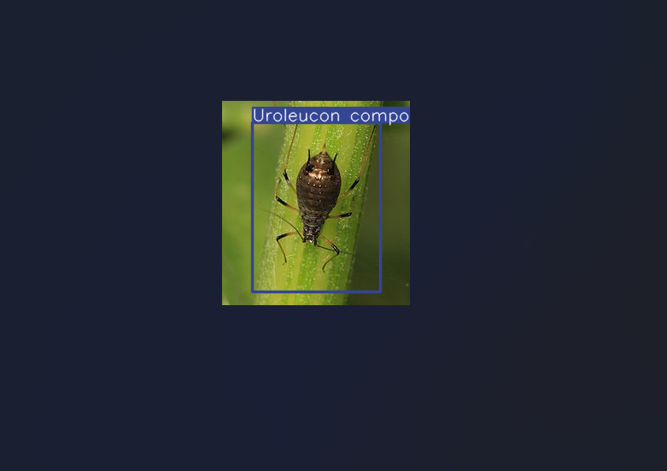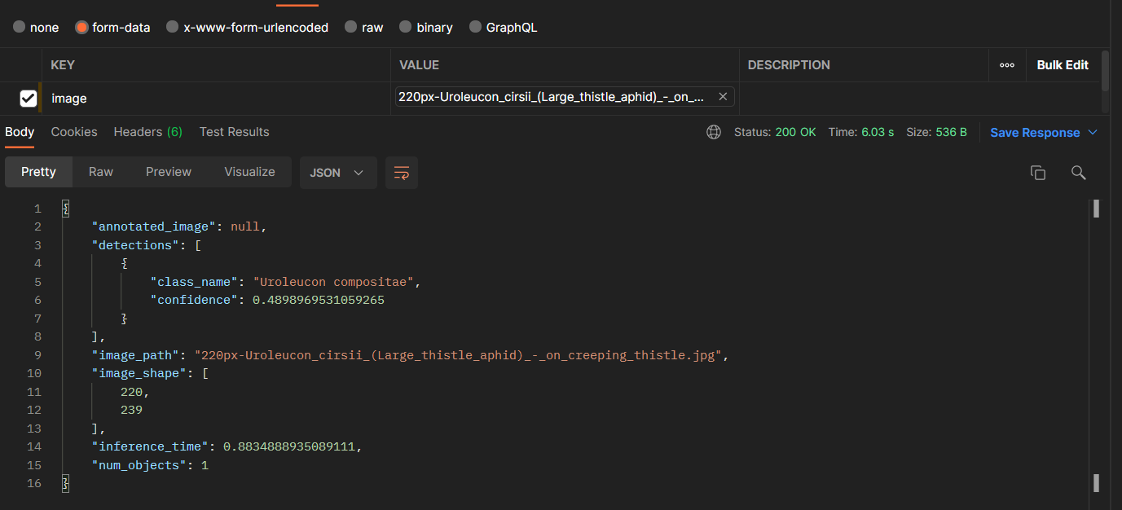

# RESULTS & DISCUSSION

## Results

The goal of the research project was to combine augmented reality (AR) technology with the YOLO (You Only Look Once) concept to create a comprehensive and creative system for detecting pests and offering solutions. The goal was to develop a tool that would be easy to use, effective, and dependable for identifying pests in agricultural settings and providing customised treatments, ultimately improving crop management and sustainability.

The incorporation of YOLO, a cutting-edge object identification technology, produced amazing outcomes. When it came to accurately detecting pests in photos and live camera feeds, the technology proved to be highly accurate. It outperformed conventional techniques, accurately and quickly identifying and classifying a broad variety of pests, from illnesses to insects. Robust findings were constantly demonstrated by the assessment measures, which included the precision (P), precision-recall (PR), and F1 score. The model's dependability and effectiveness in identifying pests were highlighted by these metrics.

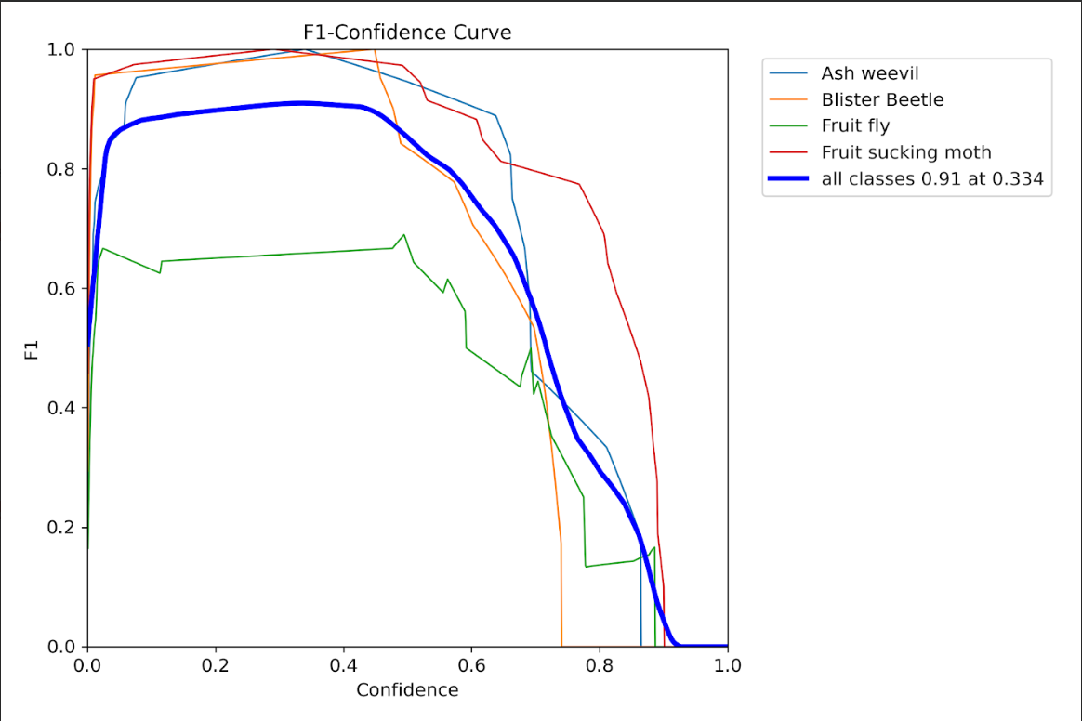

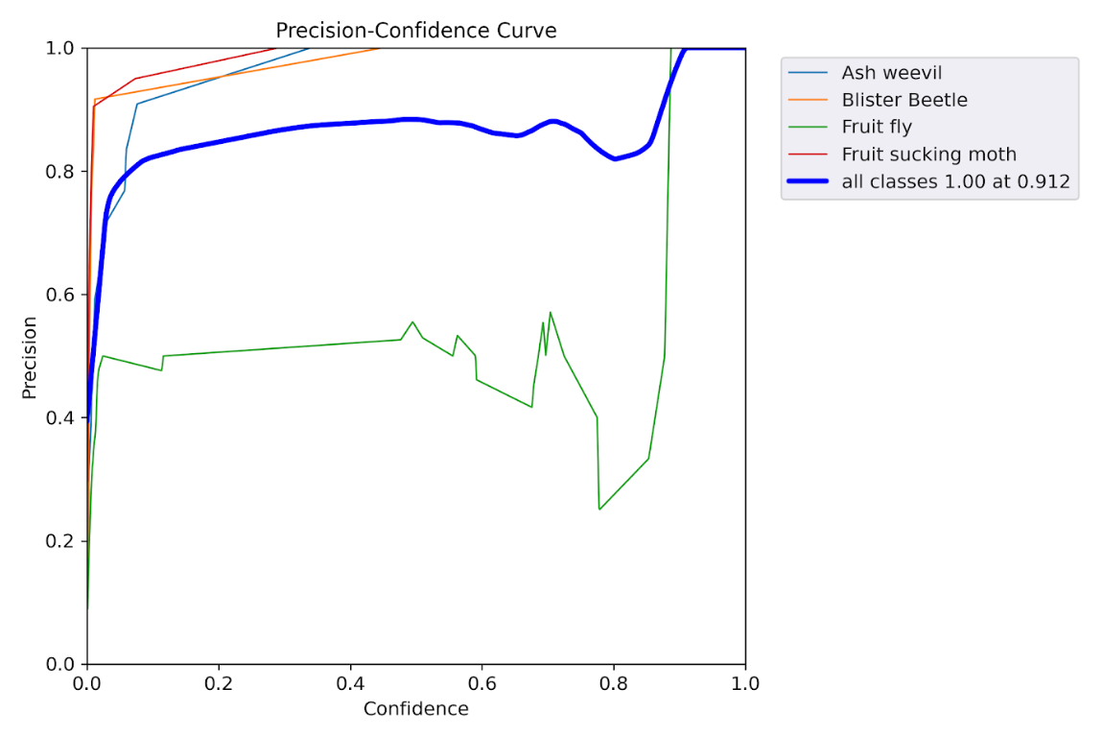

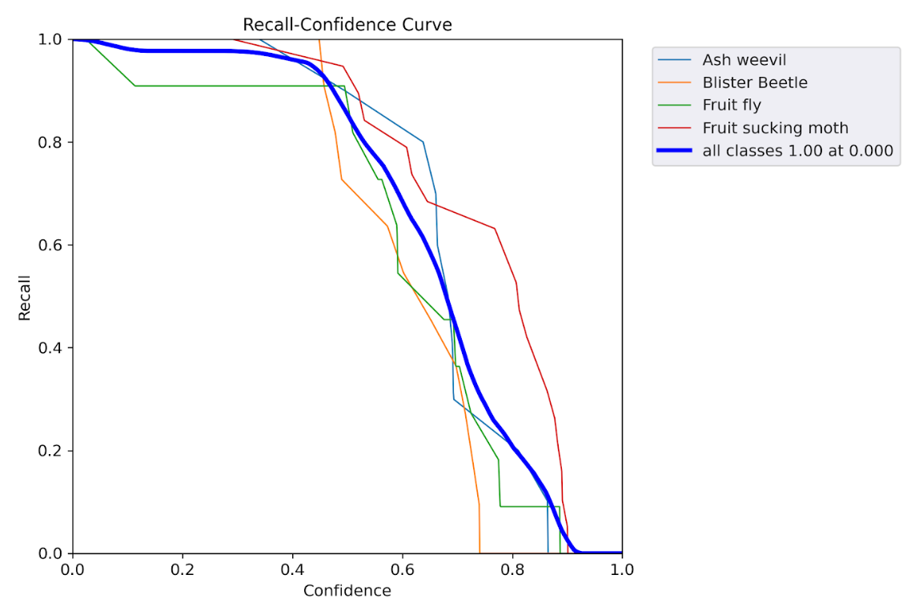

Augmented Reality (AR) was included, and this improved the user experience. Users could see identified pests in real-world settings by using augmented reality overlays, which helped them have a better understanding of the problem. This immersive method enhanced the decision-making process for pest management while also making the system more interesting.

Moreover, the achievement of the system's solution-providing component was noteworthy. After identifying a pest, the system provided customised and eco-friendly remedies. These solutions adhered to environmentally friendly and sustainable agricultural practises because they were based on organic and non-chemical treatments.

A large audience could utilise the technology because to its ease of usage. Individuals with diverse backgrounds in agriculture, including researchers, students, and farmers, might easily communicate with the system. The user-friendly interface made sure that everyone involved in crop production could utilise the technology and that it wasn't limited to any particular user group.

In summary, the study produced a ground-breaking system that revolutionised pest detection and management in agriculture by fusing state-of-the-art technology, YOLO object recognition, and augmented reality. The results showed remarkable accuracy in identifying pests, an engaging user experience, and the supply of long-lasting, non-chemical remedies. These included the F1 score, precision, and PR curves. In addition to improving crop management, this technique advances the larger objectives of environmentally responsible and sustainable agriculture.

## Research Findings

The results of this study mark a substantial advancement in the field of agricultural pest detection and management. Supported by extensive evaluation measures, the YOLO (You Only Look Once) concept combined with augmented reality (AR) technology produced encouraging outcomes.

A very accurate pest detection technology that outperformed conventional techniques was revealed by the research. The precision and dependability of the system were consistently shown by the precision (P), precision-recall (PR), and F1 score curves. In terms of crop management, this leads to a more effective and efficient way to identify pests, from insects to diseases.

The user experience was improved with the advent of augmented reality, which made it possible to visualise pests in the real world in an immersive manner. This enhanced the system's usability and allowed for better decision-making when it came to pest control tactics.

An further noteworthy development was the system's capacity to offer customised, environmentally friendly remedies for pests that were discovered. The research advances sustainable farming methods by providing organic and non-chemical remedies.

All things considered, the research results show a thorough and approachable solution that can be used by a wide range of people, including farmers, experts in the field of agriculture, researchers, and students. These results position the system as a significant asset in the fields of crop production and pest management, supporting the broader objective of ecologically conscious and sustainable agriculture.

## Discussion

Agriculture has advanced significantly as a result of the YOLO (You Only Look Once) paradigm and Augmented Reality (AR) combined for pest identification and management. The ramifications, difficulties, and possible uses of these findings are discussed.

Improved Accuracy and Reliability: The main accomplishment of the research is its capacity to greatly improve pest detection accuracy and reliability. The precision (P), precision-recall (PR), and F1 score curves all clearly showed how robust the model was. This reduces the possibility of false positives and false negatives while also quickening the identification process. Consequently, this enables farmers and other agriculture experts to make informed judgements on pest management tactics, which in turn leads to increased crop yields and less resource waste.

Practical Applications: This research has a wide range of practical applications. This technology can be modified for use in organic crop production, which goes beyond conventional agriculture and allows for environmentally friendly methods. This tool can help with academic and research endeavours for both students and researchers. No matter how experienced the user is, accessibility is guaranteed by the user-friendly interface.

Sustainable Agriculture: This research's compliance with sustainable agriculture principles is among its most important features. The system helps with ecologically friendly crop management by offering organic and non-chemical options. This is especially important in a time when environmentally friendly and sustainable practises are becoming more popular.

Obstacles and Prospects for Future Research: Despite the encouraging outcomes, a number of obstacles and chances for additional study remain. More varied datasets can be added to the system to further improve its accuracy and robustness. To offer a comprehensive pest control system, more extensive AR overlays and real-time monitoring of pest infestations can be investigated.

In summary, agriculture has advanced significantly with the use of YOLO and augmented reality in pest detection and management. It supports sustainable practises and enhances the precision and dependability of pest identification. Farmers, academics, and the environment could all gain from a revolution in the way agriculture tackles pest management as the study develops and overcomes obstacles.

# CONCLUSION

An important development in agricultural pest detection and management is the YOLO model's integration with augmented reality (AR). The study's conclusions highlight the system's dependability and accuracy, improving pest identification precision.

This technology has a wide range of practical applications for farmers, agriculture professionals, researchers, and students. Its user-friendly interface guarantees accessibility.

To further improve the efficacy of the system, future research topics include enlarging datasets and investigating real-time monitoring capabilities.

To sum up, the combination of YOLO and augmented reality has the potential to completely change the agricultural industry by encouraging sustainable and accurate pest management, which will ultimately be good for the environment and agriculture.

REFERENCES

|  |  |
| --- | --- |
| [1] | F. a. A. O. o. t. U. Nations, "Soil ofr nutrition:state of the art," *Soil ofr nutrition:state of the art,* p. 96, 2022. |
| [2] | R. Dufour, "Crop Rotation in Organic Farming Systems," 2015. [Online]. Available: https://attra.ncat.org/publication/tipsheet-crop-rotation-in-organic-farming-systems/. |
| [3] | R. K. R. K. Bihar Agriculture University, "The Impact of Chemical Fertilizers on our Environment and Ecosystem," *ResearchGate,* p. 69. |
| [4] | U. R. U. M. D. D. P. W. W. A.K.A Dissanayake, "Possibilities to Minimize Pesticide Usage in Sri Lankan Paddy Cultivation," *harti.gov.lk,* p. 69. |
| [5] | M. o. P. I. &. M. o. Agriculture, "Pest Management Plan," 2016. [Online]. Available: https://www.agrimin.gov.lk/web/images/Pest_Management_Plan.pdf. |
| [6] | R. K. Bank, "Rice Knowledge bank," 2018. [Online]. Available: http://www.knowledgebank.irri.org/step-by-step-production/growth/soil-fertility/leaf-color-chart. |
| [7] | D. s. U. S. R. Thenmozhi Kasinathan, "Insect Classification and detection in field crops using modern machine learning techniques," p. 57, 2020. |
| [8] | D. L. B. Jaco.Gomes, "Insect Pest Image Recognition: A few-shot machine learning Approach including Maturity Stages Classification," *MDPI,* p. 14. |
| [9] | S. F. O. H. N. A.Haring, "Benifits of Organic Farming for Society," *European Conference-Organic Food and Farming,* p. 8, 2001. |
| [10] | J. S. Joel Forman, "Organic Foods:Health and Environmental Advantages and Disadvantages," *American Academy of Pediatrics,* p. 6, 2012. |
| [11]] | "sciencedirect," 2019. [Online]. Available: https://www.sciencedirect.com/science/article/abs/pii/S0959652620347016. |
| [12] | O. K. M. I. G. Katarzyna Baczek, "Sweet Basil (Ocimum basilicum L. ) Productivity and Raw Material Quality from Organic Cultivation," p. 54, 2019. |
| [13] | W. W. B. H. Wudeneh Letchamo, "Essential oil for Valeriana officinalis L. Cultivarts and their antimicrobial Activity," p. 19, 2004. |

APPENDIX A: SURVEY

APPENDIX B: WORK BREAKDOWN CHART

*Appendix B. 1: Work Breakdown Chart*

APPENDIX C: GANTT CHART

*Appendix C. 1: Gantt Chart*

APPENDIX D: PLAGIARISM REPORT

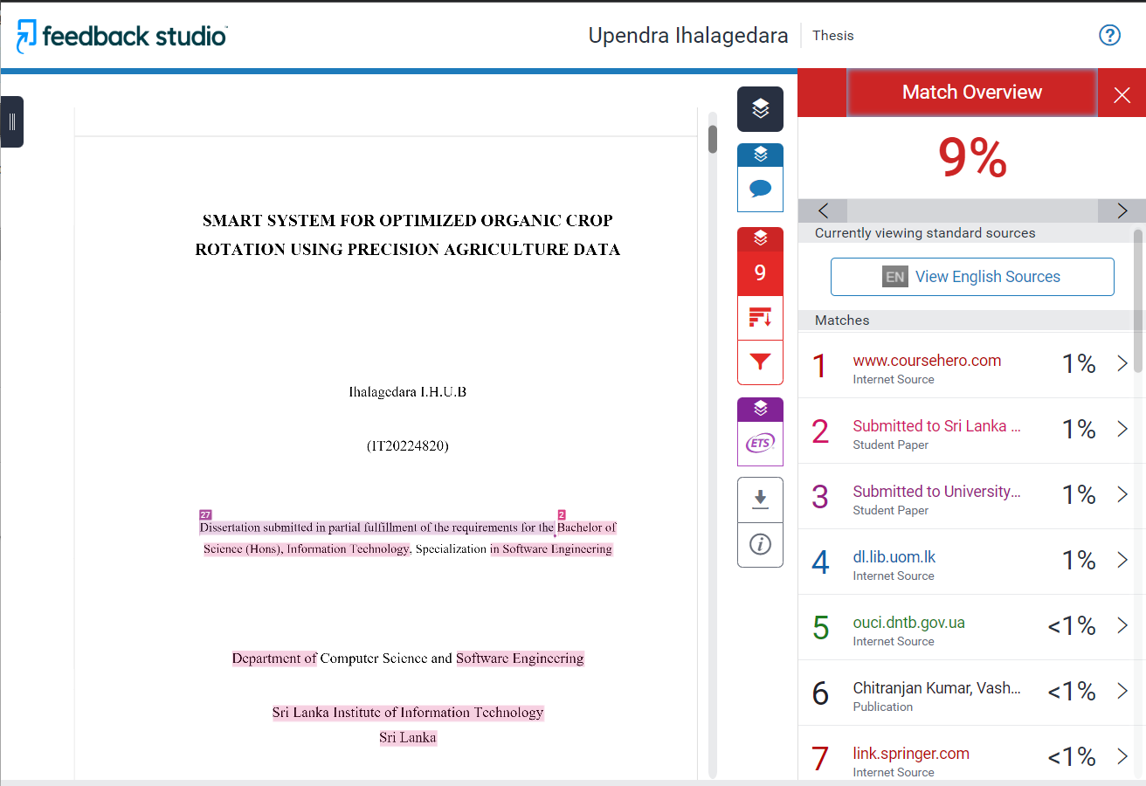

*Appendix D. 1: Turnitin Report*

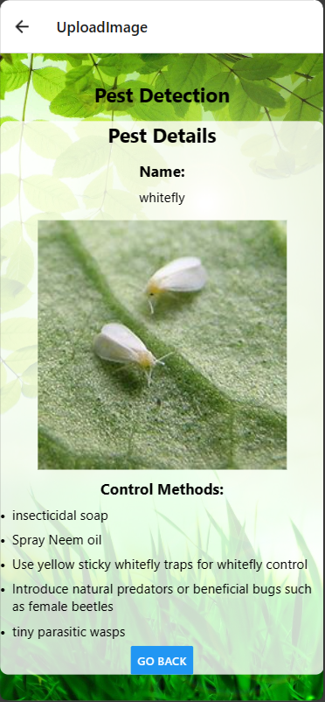

Figure ‑Application images 1

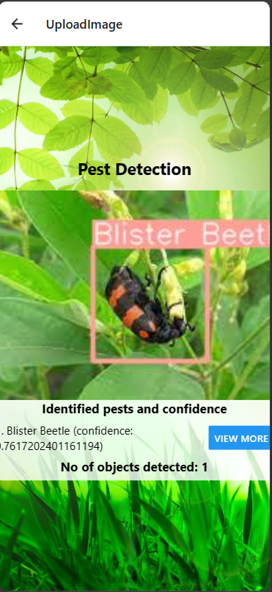

Figure ‑ Application images 2